Bridgepoint Parts Catalog

Section VII: Solenoids Page 1

PHY169-070

Solenoid Valve - Vacuum

12VDC

Hydramaster: Maxx 450D, Maxx 470D, Maxx 550, Boxxer 421 & all CDS units.
Bridgepoint: Javelin
Vent Plug: PHY106-014
Barb1/8” X 1/8”MPT: BR002

PWM-A140

Solenoid Valve - Vacuum

12VDC

White Magic: Pro1000, Pro1200, Pro2000, Pro 1800, Pro1900, Rebel, Commander & Commander HO.

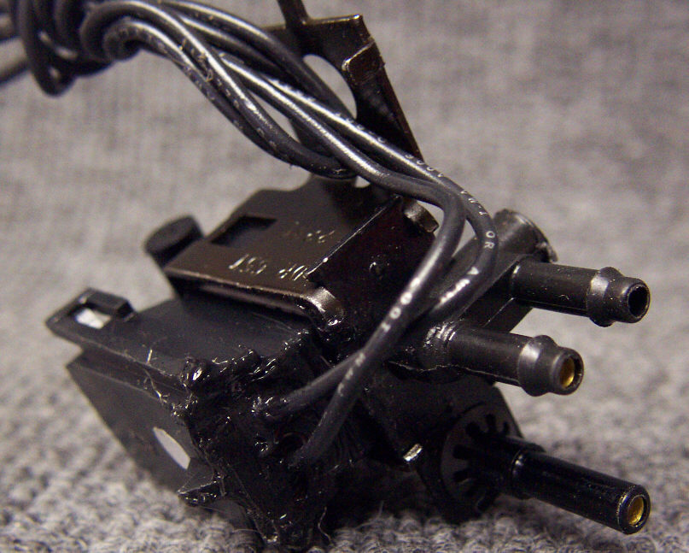
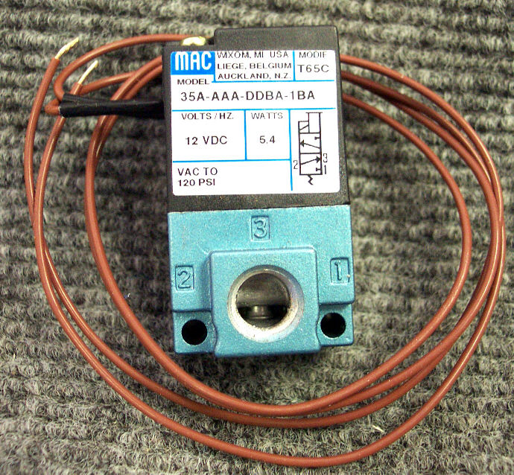

PHY169-082

Solenoid Valve - Water

12VDC
Hydramaster: Hot water dump solenoid on Boxxer 421, Maxx 450D, Maxx 470D & Maxx550.
Bridgepoint: Javelin
Repair kit: PDE41-31

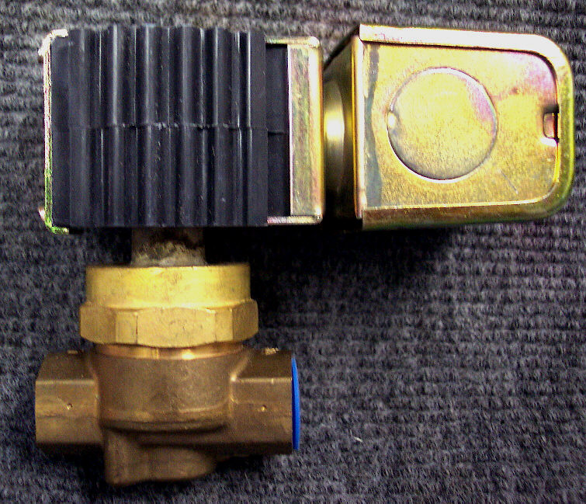

PHY169-120

Solenoid Valve - Water

12VDC

Hydramaster: Incoming water solenoid valve on all machines with electric incoming water control system. Hot water dump solenoid on the Boxxer 427, Spitfire 4.0, Crossfire 3.7, Crossfire 4.2 & Crossfire 4.4. APO priming solenoid on CDS 4.8, CDS 4.6, Maxx 450D, Maxx 470D and Maxx 550.
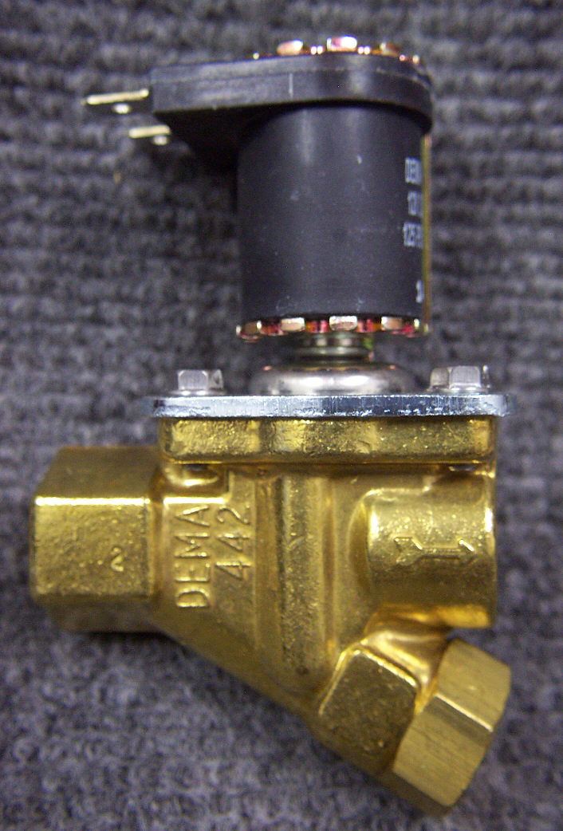

PP15-808085

Solenoid Valve – Water

12VDC

Prochem: Hot water dump solenoid on all heat exchanger machines.
(Prochem part # 15-808105)
Bridgepoint: System IV, Saber & Lancer.
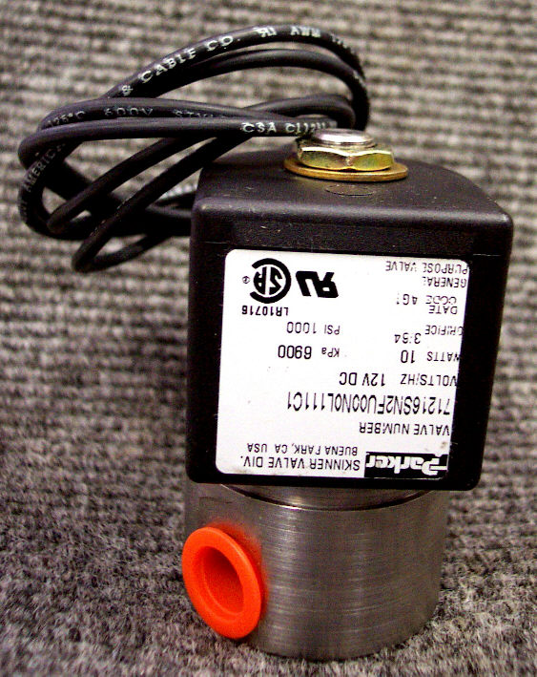

PP35-901004

Solenoid Valve - Kerosene

12VDC

Prochem: Burner Fuel inlet solenoid 100A, 150 and Oil Fired TM.
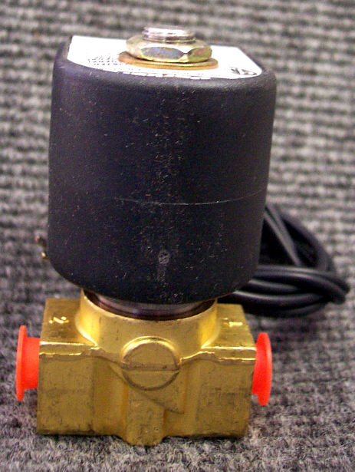

PP66-945280

Maintenance Kit for Solenoid

Valve PP15-808085

Also used for servicing the By-pass manifold and orifice.
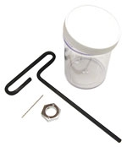

PWM-J0285

Solenoid Valve – Water

12VDC

White Magic: Pro1600, Pro1800, and Pro1900
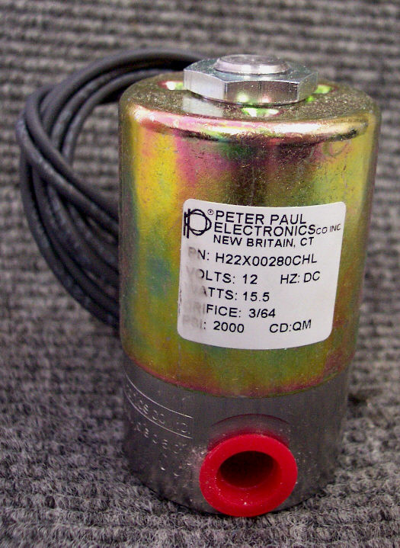

PP35-901002

Solenoid – Engine Starter

12VDC
Prochem: Blazer, Blazer Plus, Cub, Blazer XL, CubXL, 150, 100A,
Oil Fired TM & Trailblazer.
Hydramaster: Bobcat, Aquacat, Hydracat 3.5, Hydracat 4.0,
Crossfire 3.7 & Crossfire 4.2H.
(Hydramaster part # 157-016)

Bridgepoint: System IV & Saber

PFR691656 can be substituted if desired or necessary.

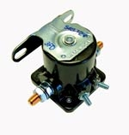

PWM-J0285R

Repair Kit for Solenoid Valve

PWM-J0285

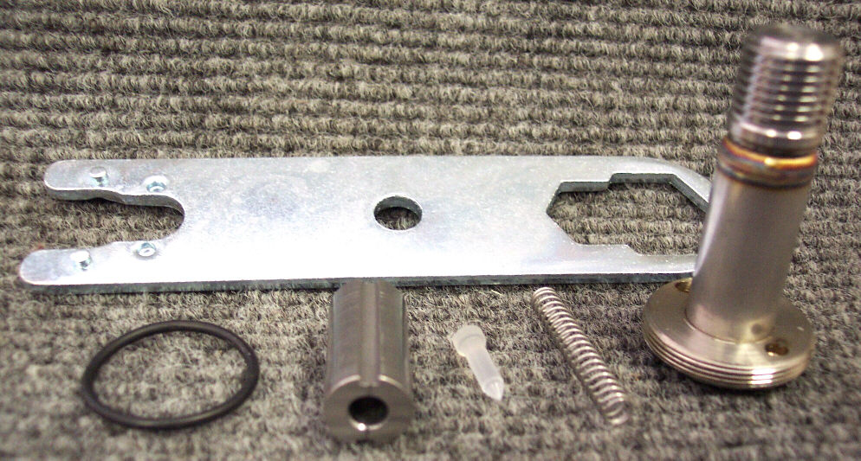

PFR691656

Solenoid – Engine Starter

12VDC
Bridgepoint: Dagger
Hydramaster: Boxxer 421, Spitfire 3.2 & Spitfire 4.0
(Hydramaster part # 157-012)

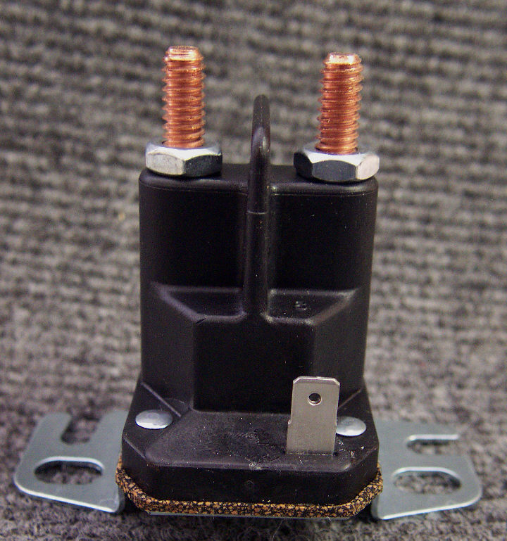

Bridgepoint Parts Catalog

Section VII: Solenoids Page 2

PP42-902149

Solenoid – Fuel Nissan

Carburetor

Prochem: 800A, Bear, Everest, Everest HP, Power Vac II, Performer & Performer 405

PP36-900182

Solenoid – Rotary

Exhaust Diverter

Thermostatically Controlled

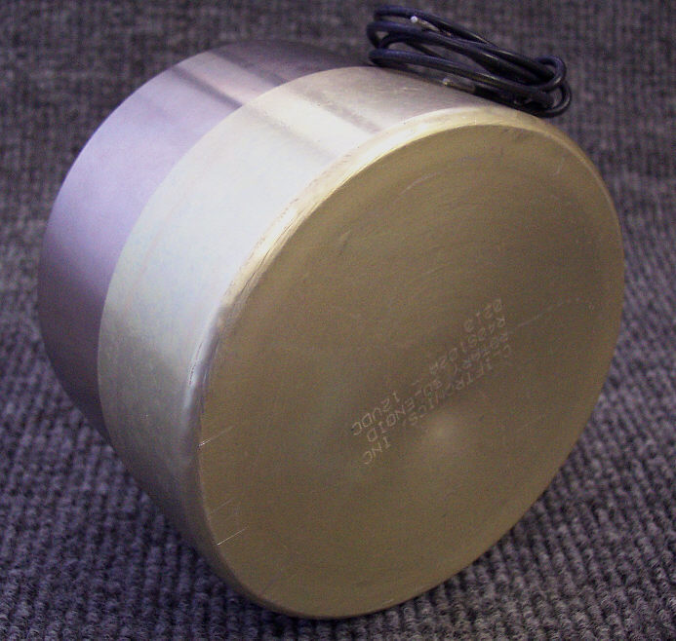
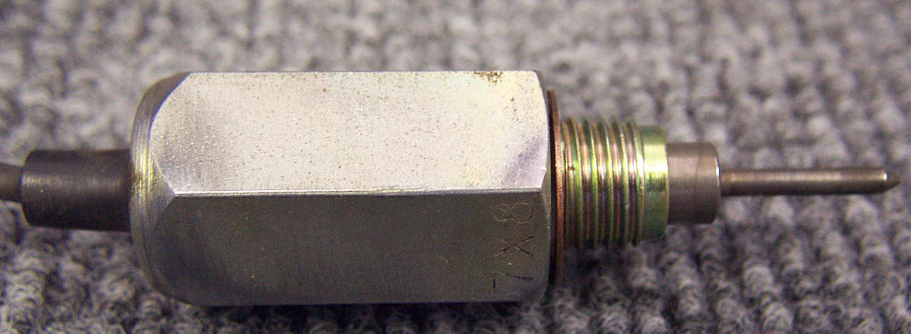

PSD023

Solenoid Assembly

Steamin Demon

115 VAC
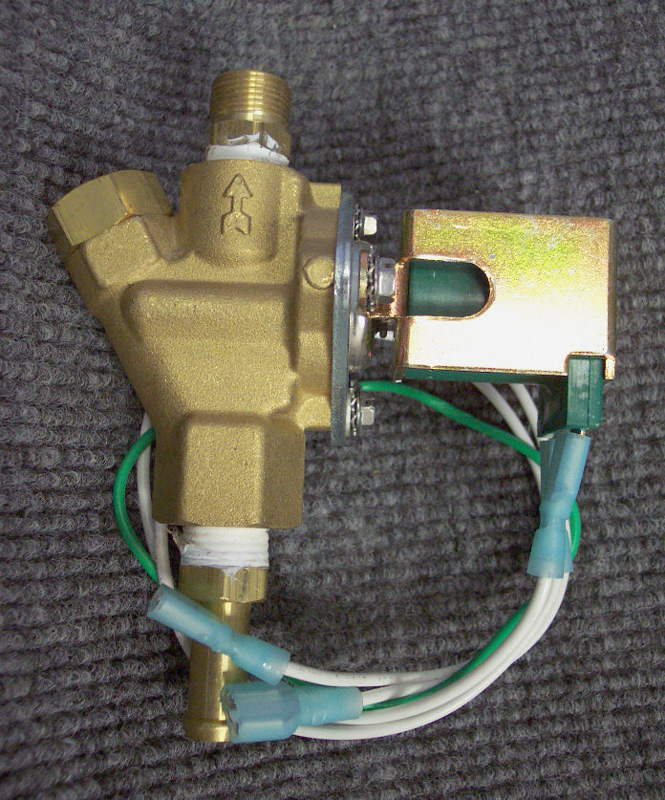

PP42-902147

Solenoid – Starter Nissan

Prochem: 800A, Bear, Everest, Everest HP, Power Vac II, Performer & Performer 405
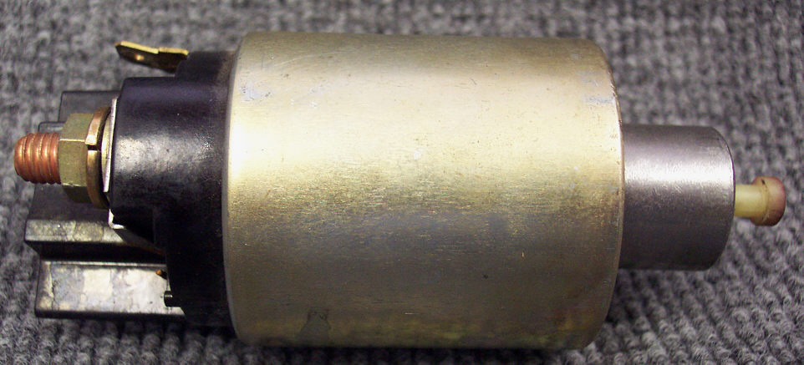

PTPD0710

Solenoid Valve Assembly

MB07
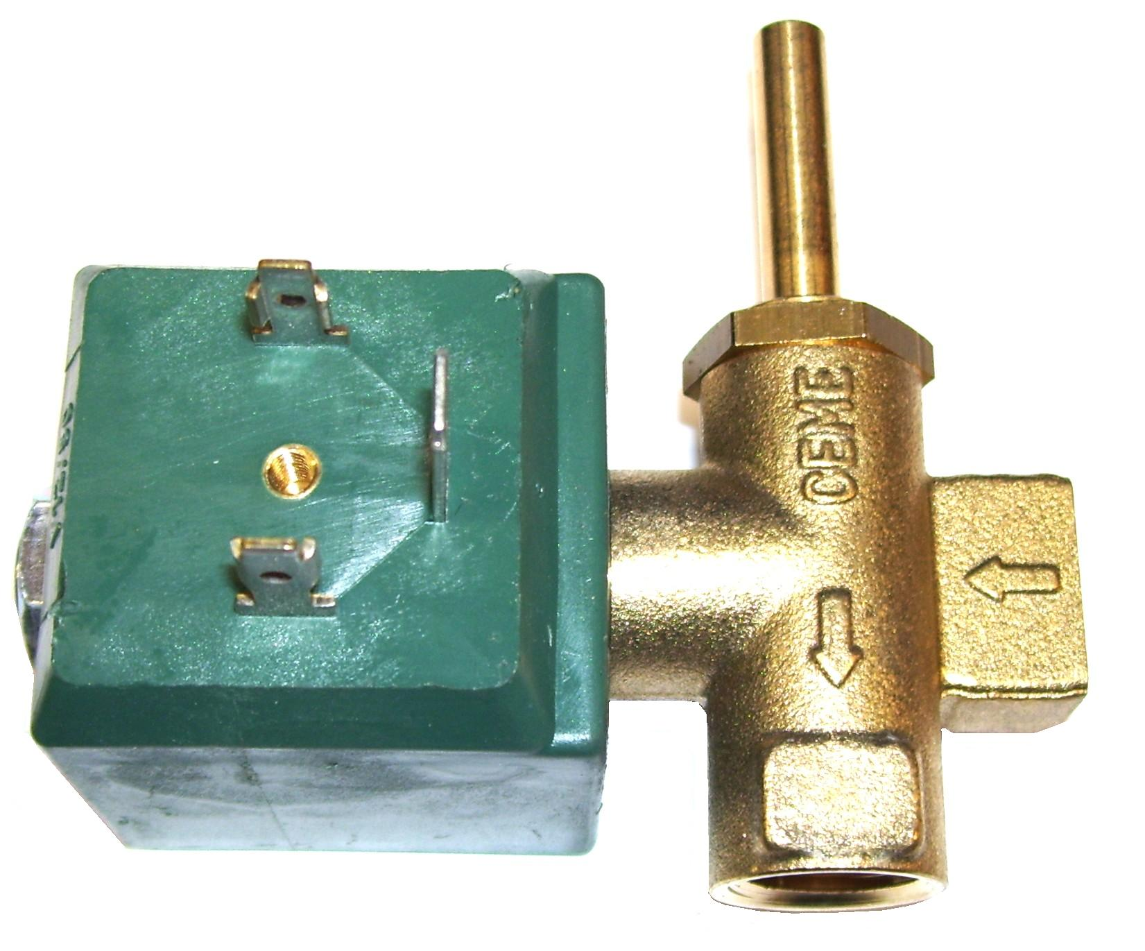

PHY157-037
Solenoid – Charging Switch
50amp Charging Systems

Hydramaster: Boxxer 421 &
Boxxer 427
